**RECIPE APP**

**#4WEEK 4APP CHALLENEGE**

2ND APP

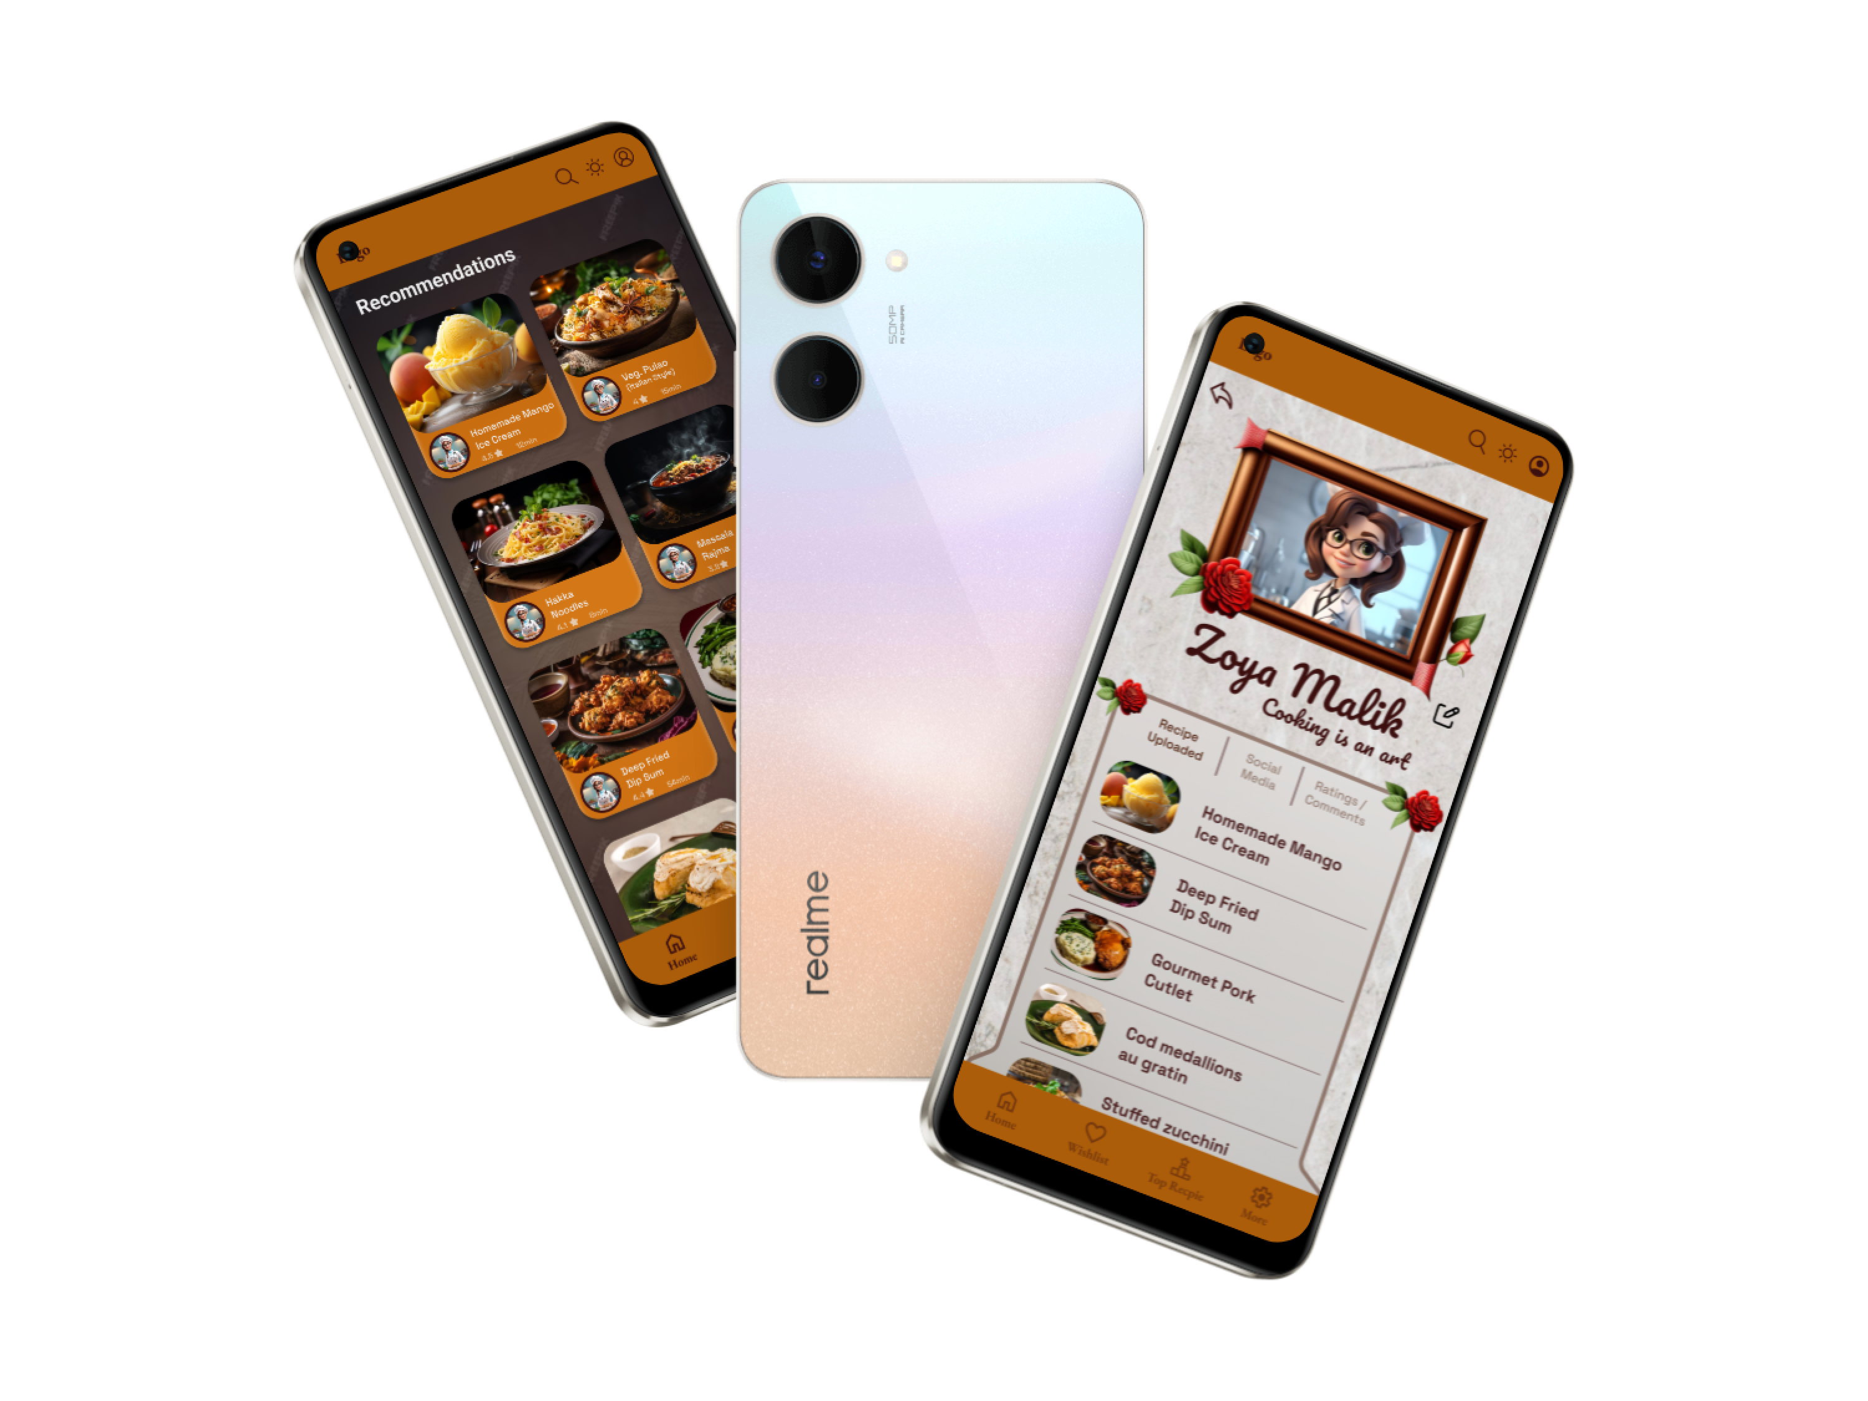

Android view

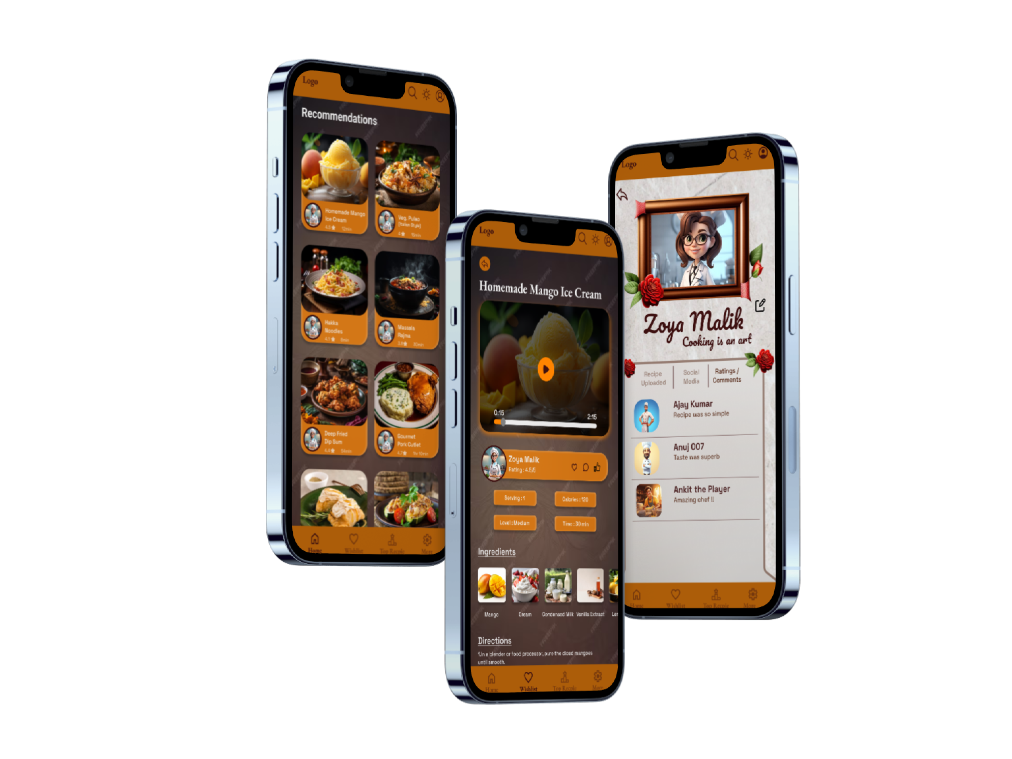

i-phone view

<https://www.figma.com/proto/hYGSMXi1El2jceoXIl7yIU/app-practice-2?page-id=119%3A182&type=design&node-id=819-1057&viewport=387%2C387%2C0.08&t=eKBcLQTRFIyy9ztH-1&scaling=scale-down&starting-point-node-id=819%3A1057&mode=design>

In this app, the home page features recommended recipes, and it remains stationary.

On the wishlist page, you can open a recipe, and all the cards from the home page and the top recipe page are prototyped onto it. This includes functional wishlist, comment, and like buttons/icons.

The top recipe page displays recipes based on ratings, along with their respective creators.

Moving to the profile page, it's distinctly different from the others, so please don't judge it based on the color palette. This page includes editable frames, avatars, background settings, and of course, your name. Frames, avatars, and background settings can be disabled using a dedicated "None" button.

The app also supports a dark mode.

If the initial loading animation doesn't occur, a reset is recommended. Additionally, delays in animation might be due to internet speed, so please be patient in such cases.

I hope this clarifies the features of the app.